CHAPTER 3: Cells
Worksheet 3.6

Photosynthesis
Answers
Green plants are producers
1. Green plants produce their own food via the process of photosynthesis.
(a) Write a word equation for photosynthesis.
carbon dioxide + water → glucose + oxygen

(b) The drawing shows the surface epidermal cells of a leaf and the mesophyll cells beneath.
The mesophyll cells contain many green bodies labelled X.
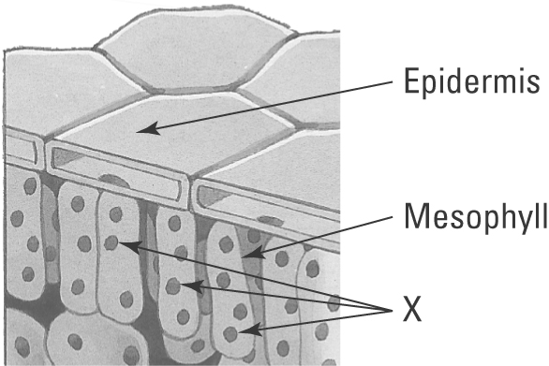 | (i) Identify the green organelles labelled X.  Chloroplasts  (ii) Inside these organelles is a green compound. Name this compound.  Chlorophyll  (iii) Explain the importance of this compound to the plant.  Chlorophyll absorbs the sun’s energy, which the plant uses to make glucose and oxygen.
Carbon dioxide — an important raw material
2. Plants need to absorb carbon dioxide into their leaves to carry out photosynthesis.
(a) Name the structure in the leaf through which the carbon dioxide is absorbed from the air.
Stomate

(b) The following data records the carbon dioxide concentration (in parts per million) in the air just above the flower heads of a field of maize throughout a sunny day.
(i) Draw a line graph of this data and draw a smooth curve of best fit.
Time (24-hour clock) CO₂ (ppm)  0300 380  0600 350  0900 310  1200 280  1500 290  1800 370 |  | 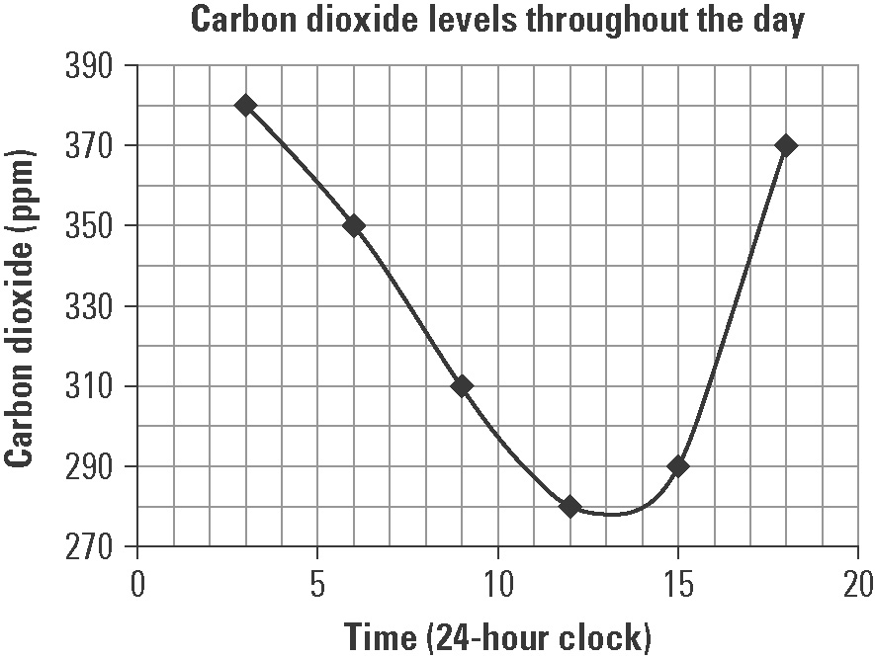
(ii) At what time of day was the carbon dioxide level lowest above the maize?
About 1300 hours (1 pm)

(iii) Explain why the carbon dioxide levels are lowest in the air at this time.
The sun is high in the sky, so the maximum amount of sunlight is reaching the plant and it is actively photosynthesising and absorbing carbon dioxide from the air.

